|  |  |  |  |
| --- | --- | --- | --- |
| **Group No.** | **Group Members** | | |
|  | **ID** | **Name** |
| **3** | 1. | 20-42794-1 | **FAHIM, SHAH NAWAJ** |
| 2. | 20-42752-1 | **HOWLADER, MD. SHAKIB** |
| 3. | 20-42195-1 | **LEO, NAFINUR** |
| 4. | 20-42870-1 | **HASSAN, MD. ALIF** |
| 5. | 20-42853-1 | **RAHMAN, HASIBUR** |
| 6. |  |  |

**Laboratory Experiment Report**

Electronic Devices Laboratory

Semester: Spring 2021-22

|  |  |  |
| --- | --- | --- |
| **Experiment No.:** 01 |  | |
| **Experiment Title:** Determination of Characteristic Curve of a Diode |  | |
| **Date of Experiment:** 23-01-2022 | | **Date of Report Submission:** 16-03-3022 |

**Marking Rubrics for Laboratory Report (to be filled by Faculty)**

|  |  |  |  |  |
| --- | --- | --- | --- | --- |
| **Objectives** | **Unsatisfactory (1)** | **Good (2-3)** | **Excellent (4-5)** | **Marks** |
| **Theory** | The relevant theories are not being described properly. | Part of the relevant theories are described with proper mathematical expression and circuit diagrams (if any) | All the relevant theories are included with proper descriptions, mathematical expressions and circuit diagrams. (if any) |  |
| **Simulation circuits & Results** | Simulation circuits are not included in this report. | Partial simulation circuit results are included in this report. | All the simulation circuits are included in this report with appropriate results. |  |
| **Report Question, Discussion on Comparison between theoretical and simulation results** | Cannot reach meaningful conclusions from experimental data; Cannot summarize or compare findings to expected results | Can extract most of the accurate data. Answers to the report questions are partially correct; Summarize finding in an incomplete way | Can extract all relevant conclusion with appropriate answer to the report questions; Summarize finding in a complete & specific way |  |
| **Organization of the report** | Report is not prepared as per the instruction. | Report is organized despite of few missing sections as per the recommended structure. | Report is very well organized. |  |
| **Comments** | Assessed by (Name, Sign, and Date) | | Total (out of 20): |  |

**Experiment title:** Determination of Characteristic Curve of a Diode

**Relevant Theory:**

An n-type and a p-type material are simply joined together to form a semiconductor diode [1]. As seen in Figure 1, it is a pn junction. The pn junction is made up of p-type semiconductor material in contact with n-type semiconductor material, as the name suggests. Silicon, germanium, gallium arsenide, and other semiconductor materials can be used to make pn junctions. However, because silicon is the most extensively used material in microelectronics, we shall focus on it. In practice, the p and n regions of a silicon crystal are one and the same. Within a single piece of silicon, distinct doping regions (p and n regions) are created to form the pn junction. The diode is reverse biased when a negative voltage is supplied to the pn junction. As a result, free holes and electrons are drawn towards the crystal's end and away from the junction. As a result, all available carriers are drawn away from the junction, extending the depletion zone. Under such circumstances, there is no current flow. The diode functions in forward bias when the applied voltage is positive. The depletion region shrinks as a result of this. The positive applied voltage attracts electrons in the p-type end, whereas the negative applied voltage attracts holes in the n-type end.

**Diode Characteristics:**

For forward bias and reverse bias operations, there are a variety of current scales. When the P-region is made positive and the N-region is made negative, the forward portion of the curve indicates that the diode conducts simply. When the Pregion is made negative and the N-region is made positive, the diode conducts almost little current in the high resistance path. The holes and electrons are now being drained from the connection, increasing the barrier potential. The reverse current part of the curve indicates this condition. The dotted segment of the curve represents the ideal curve that would have resulted if avalanche collapse had not occurred. When a diode is forward biased, current (IF) is conducted in the forward direction. The value of IF is exactly proportional to its size.

The number of minority current carriers involved in reverse current transmission is relatively large.

small. In general, this indicates that reverse current remains constant for a significant portion of the reverse current cycle voltage. There is a very little rise in reverse voltage when a diode is raised from the start.a shift in the reversing current. The Current increases dramatically at the breakdown voltage (VBR).quickly. At this point, the voltage across the diode is rather consistent.

|  |  |  |
| --- | --- | --- |
| **APPARATUS:** |  | |
| **No.** | **Apparatus** | **Quantity** |
| 1 | Diode | 1 |
| 2 | 10 k Resistance | 1 |
| 3 | Project Board | 1 |
| 4 | DC Power Supply | 1 |
| 5 | Multimeter | 1 |

**Calculation:**

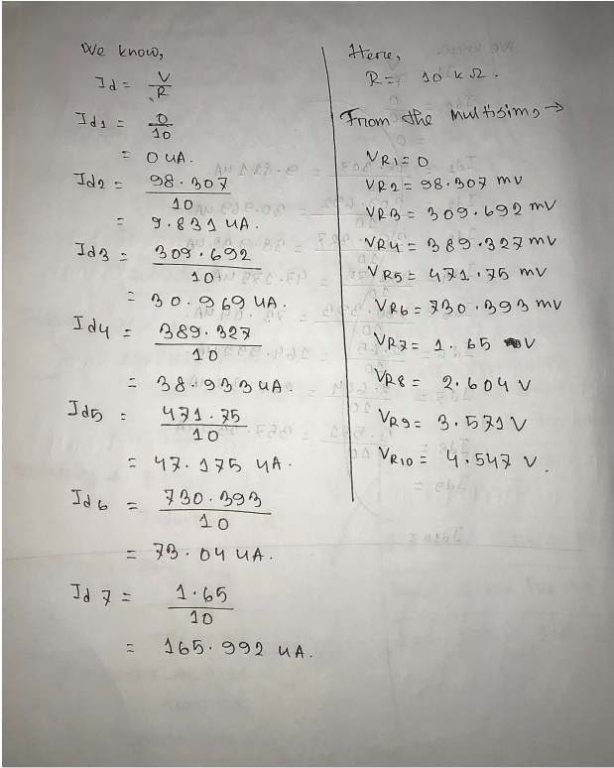

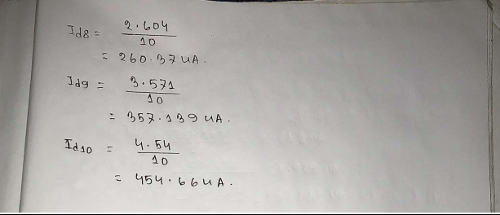

**Table:**

|  |  |  |  |
| --- | --- | --- | --- |
| **Vin** | **VD** | **VR** | **Id = VR/(10K)** |
| 0 | 0mV | 0V | 0 uA |
| 0.5 | 485.7mV | 14.305V | 1.4305 uA |
| 1 | 573.5 | 426.5 | 42.65 |
| 1.5 | 593.02 | 906.98 | 90.698 |
| 2 | 604.17 | 1.39 | 139.58 |
| 2.5 | 1.8 | 611.98 | 188.8 |
| 3 | 2.38 | 617.9 | 238.2 |
| 3.5 | 2.87 | 622.8 | 287.7 |
| 4 | 3.37 | 626.99 | 337.30 |

**Simulation:**

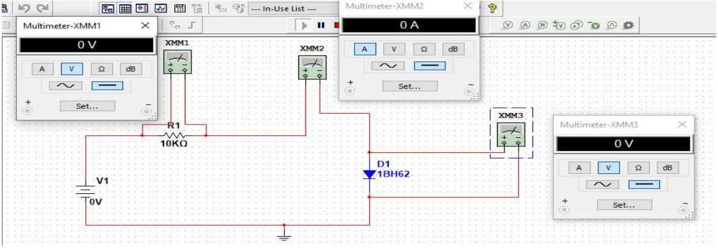

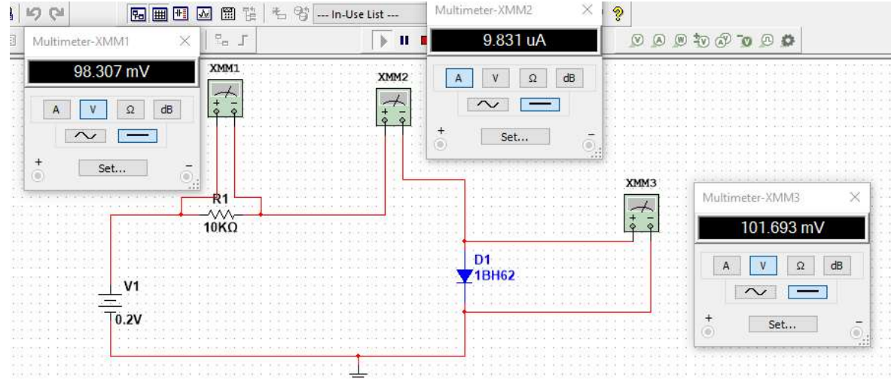

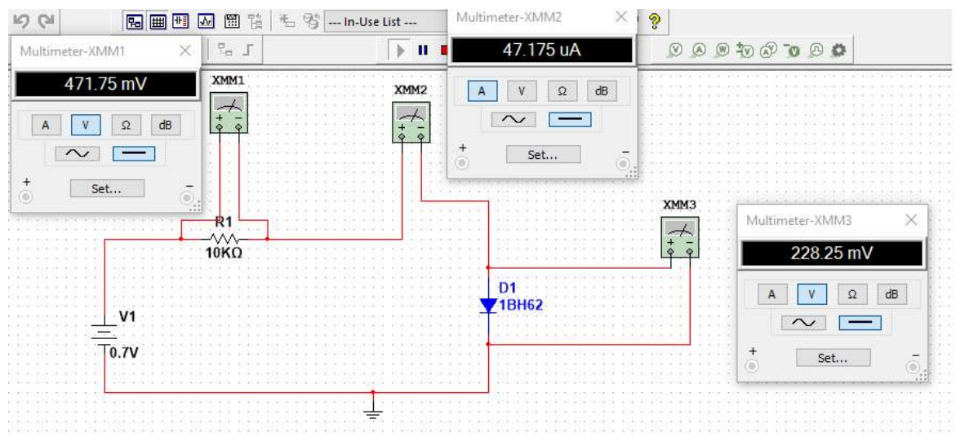

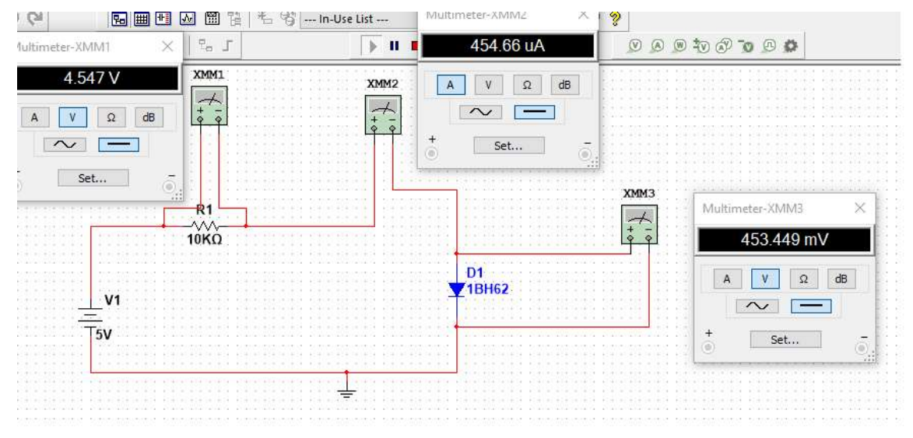

**(6) Discussion:** 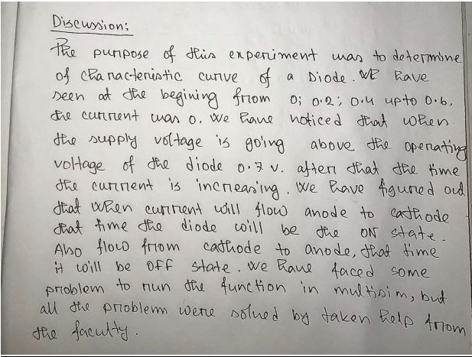

**(7) References:**

1. Robert L. Boylestad, Louis Nashelsky, Electronic Devices and Circuit Theory, Ninth Edition, 2007-2008

2. Adel S. Sedra, Kennth C. Smith, Microelectronic Circuits, Saunders College Publishing, 3rd ed., ISBN: 0-03-051648-X, 1991.

3. American International University–Bangladesh (AIUB) Electronic Devices Lab Manual.

4. David J. Comer, Donald T. Comer, Fundamentals of Electronic Circuit Design, john Wiley & Sons Canada, Ltd.; ISBN: 0471410160, 2002.